**TOWARDS A NEW BODY OF KNOWLEDGE FOR GEOGRAPHIC INFORMATION SCIENCE AND TECHNOLOGY**

**Danny VANDENBROUCKE[1] and Glenn VANCAUWENBERGHE[2]**

*UDC:*

**SUMMARY**

Geographic information (GI) and technology has rapidly expanded and evolved over the past decades resulting in an increased need for experts in this field. However, the academic, private and public sectors active in this domain often have difficulties to find well-trained and skilled employees. The geospatial workforce often appears to be inadequately prepared to the continuously evolving GI-domain. This paper presents the results of the Erasmus project ‘Geographic Information – Need to Know (GI-N2K)’[3] which aimed at filling this gap by analyzing the demand for and supply of geospatial education and training, the creation of a European version of the Body of Knowledge for GI Science & Technology (BoK GI S&T), the development of a platform with tools for using the BoK and by testing and validating the results through real-world use cases during plugfests.

**Key words**: Body of Knowledge, Geographic Information, concept, curriculum design, hierarchy, ontology.

**A DEMAND-DRIVEN EDUCATION AND TRAINING SYSTEM**

The geospatial industry is a rapidly growing industry and involves high-value, high-tech jobs, innovative services and fast evolving technologies. In the European context, the need to prepare Europe’s GI S&T workforce that is able to answer to the requirements of the European knowledge society is driven by several European strategies and policies such as the Digital Agenda for Europe, the Smart Cities initiative, the INSPIRE directive, the European Union Location Framework (EULF) and many other initiatives. The markets of geographic information and related technologies are huge and they are still growing: e.g. the European GIS market was valued at 2.06 billion € in 2012 and is expected to reach 2.96 billion € in 2016 (Technavio, 2015). Related markets such as UAV’s will reach an estimated 6.28 billion € (European Union, 2015).

However, even if the markets are important, the handling and using of geographic data and information is a challenging task and requires specific skills. The demand for well-trained GI professionals is therefore high. Employers in the domain of GI often find it difficult to find well-trained and skilled employees, as geospatial workers appear to be inadequately prepared to answer to the challenges and opportunities in this field. The gap between existing knowledge and skills and the job market requirements is not a specific problem for the geospatial market as is illustrated by other studies (Vassiliou, 2014). It is also confirmed by important players in the market such as Shell and Google. The General Manager of Geomatics and Information Management of Shell Global Solutions stated in an phone interview in 2013:

*“Our demand for new GI professionals is growing but, despite the current economic crisis, we have difficulties in finding people with the right knowledge and skills” (Vanouden, 2013).*

Other stakeholders refer to a mismatch between education and training in the domain of Geographic Information Science and Technology (GI S&T) and the actual job requirements in the labour market. This was expressed clearly by Ed Parsons, geospatial technologist of Google during another interview in 2013:

*“A career in geospatial technology requires a combination of technical skills that are not taught as an integrated package in any meaningful way at our universities today. There are excellent postgraduate courses in GIS but these tend to be very focused on geography, which isn't a bad thing, but you don't tend to get the computer skills you need. On the other hand, there are intensive computer science courses that fail to provide the geographical knowledge needed. It is hard to get the right mix” (Parsons, 2013).*

In order to set-up a more demand-driven workforce educational and training program, there needs to be consensus about what geospatial professionals in Europe should know (knowledge requirements) and be able to do (skills requirements).

The project ‘Geographic Information - Need to Know (GI-N2K)’ aims to help making the geospatial workforce education and training system more demand driven and flexible by developing an agreed ontology for the GI S&T domain. GI-N2K builds upon the existing GI S&T BoK that was developed by the American University Consortium for Geographic Information Science (UCGIS), published in 2006 by the Association of American Geographers (DiBiase, 2006). The main objective of GI-N2K is to develop a dynamic GI S&T BoK which is in line with the latest technological developments and takes into account the European dimension. To achieve this objective, the following activities were and are still undertaken:

1. Analysis of the current situation with focus on the demand of private and public sector as compared to the existing academic and vocational training offer;
2. Revision of the content of the GI S&T BoK to bring it in line with technological developments, emerging new knowledge areas and the European context;
3. Development of tools and guidelines that allow to manage and use the GI S&T BoK for defining vocational and academic curricula, job profiles, etc.;
4. Testing of the GI S&T BoK, its tools and guidelines through participation of dedicated target groups from the private, public and academic sector.

In the next sections we discuss briefly the applied approach and the results for each of the activity lines.

**ANALYSIS OF OFFER AND DEMAND**

The first activity of GI-N2K was focusing on the analysis of the demand for geospatial education and training. In order to analyse the match between the knowledge, skills and competences that are required by employers and organizations in the field of geospatial information (demand side) and the knowledge and competences that are central in the current offer of GI S&T curricula, programmes and courses in Europe (supply side), two surveys were conducted:

1. The GI-N2K Demand Survey aimed to evaluate the current workforce demands in GI S&T and identify presumed future directions;
2. The GI-N2K Supply Survey aimed to collect information about which GI S&T courses and programmes are available in Europe and to explore which parts of the GI S&T domain are present in today’s teaching.

For both surveys the original GI S&T BoK developed by the American University Consortium for Geographic Information Science (UCGIS), was used as a starting point for the design of the questionnaires.

The aim of the GI-N2K demand survey was to assess the relevance of individual Knowledge Areas (KA) and Units of the existing GI S&T BoK and to identify additional and potentially new areas that should be included in the its new version. In total, 435 surveys were fully completed by professionals actively working in the GI S&T domain in Europe. Answers were collected from professionals working in the public sector (39%), private sector (35%), academic sector (23%) and non-profit sector (3%). Respondents were asked, among others to rate the importance of GI S&T BoK KA’s in their job on a scale between 1 (not relevant) and 6 (extremely relevant).

The aim of the GI-N2K Supply survey was to describe and analyse the current supply of GI S&T education and training in Europe in terms of course size, level and content, and to collect information on the awareness and use of the GI S&T BoK. The survey was successfully completed by 234 organisations involved in GI S&T teaching and training in Europe. A total of 570 courses on GI S&T were identified, of which 427 were on offer at the time of the survey (2014), and 143 were intended to be offered in the near future. Respondents were asked to use the GI S&T BoK to specify the content of existing and intended courses, with a maximum of 3 courses per response.

The detailed results of the survey can be found in two separate reports (Wallentin et al., 2014; Rip et al., 2014a). However, some points are highlighted here. With regard to the demand side:

* The three main sectors – public administrations, private organisations and academia – evaluated the BoK Knowledge Areas congruently;
* The GI S&T community evaluated the relevance of the current GI S&T BoK KA’s in their professional work differently. ‘Geospatial data’ and ‘Cartography and Visualization’ were considered as the most relevant BoK Knowledge Areas, whereas advanced ‘Geocomputation’ received the lowest rating.
* The gap analysis revealed several topics that are not (fully) covered in the current GI S&T BoK, including programme development, WebGIS, SDI, data acquisition and other ‘hot’ topics such as big data and augmented reality.

Table 1 provides an overview of terms and concepts respondents of the demand survey deemed missing in the current BoK.

Table 1: Keywords and topics mentioned in the demand survey that are missing in the existing GI S&T Body of Knowledge (based on Wallentin et al., 2014)

|  |  |  |
| --- | --- | --- |
| **Demand survey** | | |
| Frontend | Semantics, Semantic web | Big Data, Mass Data |
| Application Programming Interface (API) | Harmonisation | Radar Remote Sensing, Sidelooking Airborne Radar (SAR) |
| Geojson | Geoportal | Geo-marketing |
| Python | ISO Standards 19107, 19109 | Object Based Image Analysis (OBIA) |
| Plugin | Open Street Map (OSM) | 2D / 3D / 4D |
| Java, Javascript | Unmanned Aerial Vehicle (UAV) | Building Information System (BIM) |
| Object Oriented Programming | Drone | Data archive |
| Web Application | Global Navigation Satellite System (GNSS) | Augmented Reality |
| HTML5 | Open data | Indoor GML |
| RESTful | Crowdsourcing, Voluntary Geographic Information (VGI) | City GML |
| General Packet Radio Service (GPRS) | Geo-processing | Smartphone, mobile |

With regard to the supply side several other issues could be observed:

* Most of the identified courses have a study load between 0 and 11 ECTS (European Credit Transfer System), and are given on the levels of EQF5_6 and EQF7 (European Qualifications Framework).
* The current GI S&T Knowledge Areas ‘Analytical Methods’, ‘Geospatial Data’ and ‘Cartography and Visualization’ were most often indicated as the subject of the existing courses. The most popular subjects of the intended courses were ‘Data Modelling’, ‘Geospatial Data’ and ‘Analytical Methods’.
* Web services, data acquisition technologies, point cloud analysis, programming in Python, UML, XML, Qualitative GIS, and Open source software were mentioned as subjects that are relevant for teaching although they are not covered by the BoK.

The analysis of the demand against the supply revealed a need for more teaching about the subjects “Programming” and “Mobile”. The two surveys provided valuable input for the identification of new concepts that should be included in an updated version of the GI S&T BoK. Finally, the surveys also showed that the current awareness and use of the GI S&T BoK are limited, especially at the demand side (Rip et al., 2014b).

**A EUROPEAN BODY OF KNOWLEDGE FOR GI S&T**

The GI S&T BoK developed in 2006 aimed at defining a framework with a description of the key concepts defining the GI field. The BoK was conceived as a traditional hierarchical structure consisting of three levels: 10 Knowledge Areas (KA), which were divided into 73 Units which in turn were divided into 330 Topics. This meant that e.g. each topic belonged to exactly one unit and that that unit belonged to one KA only. The European scientific geospatial community evaluated the existing BoK as being too static, too much geography oriented and reflecting the US perspective (e.g. at the level of reference material used). Reinhard et al. proposed also a revision of the KA’s (Reinhard et al., 2011).

Based on these findings, an ontology based approach is envisaged, meaning that the starting point would rather be the definition of a series of concepts, without necessary linking them to a particular hierarchical level. Several types of relationships are foreseen, not only hierarchical ones such as ‘sub-concept of’ and ‘super-concept of’, and ‘pre-requisite of’ and ‘post-requisite of’, but also ‘similar with’. Such a richer set of relationships would allow to build a geospatial ontology and apply linked data concepts in the development of the platform and tools (Ahearn et al., 2013).

After an extensive discussion within the GI-N2K consortium it was decided to follow a mixed approach allowing to evolve step-by-step towards a full geospatial ontology. In a workshop in Lisbon in March 2015 (see figure 1) and a follow-up workshop in Athens in September 2015 it was decide to use the old KA’s as a sort of organizational canvas complemented with a 11th KA called ‘Web-based GI’ to cover recent technological developments.

Table 2 shows the 11 working groups. Throughout the work it was decided to drop KA6, ‘Data manipulation’, and to redistribute its content under different other KA’s. Also some of the original names of KA’s were slightly altered: e.g. ‘Data modeling’ became ‘Data modeling, storage and exploitation’.

Table 2: 11 Knowledge Areas used as organizational canvas for revision of the BoK

|  |  |
| --- | --- |
| 1. Analytical methods | 1. Geocomputation |
| 1. Conceptual foundations | 1. Geospatial data |
| 1. Cartography and visualization | 1. GI and Society |
| 1. Design and Setup of Geographic Information Systems | 1. Organizational and Institutional aspects |
| 1. Data modeling, storage and exploitation | 1. Web based GI |
| 1. Data Manipulation |  |

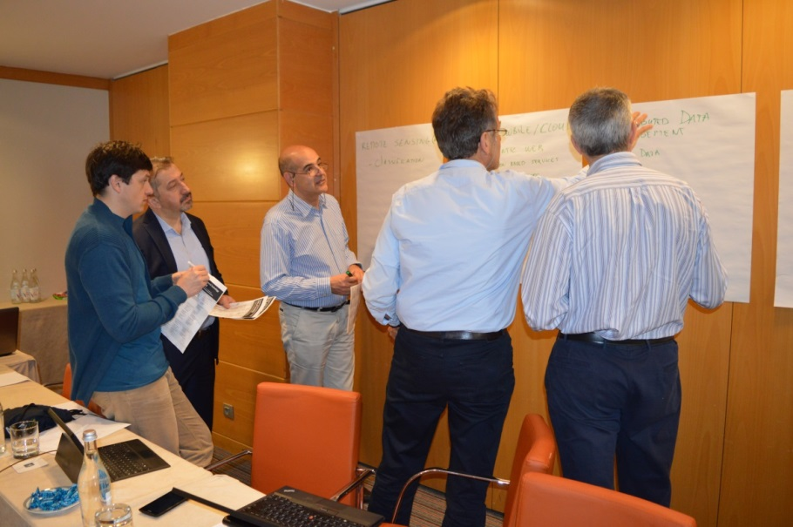

Figure 1: consortium members at work during the workshop in Lisbon (2015)

The 11 working groups were then working for 12 months (from May 2015 to April 2016) in two iterations to define the concepts (topics and units) and their content. In order to do so, the working groups set-up a network of experts for their KA by contacting known experts and by selecting other experts after a public call for experts. In the first round, the existing list of topics and units were evaluated and a decision was made, either to drop, revise (minor/major) or keep them ‘as-is’. In addition, working groups could also propose new concepts. For each of the retained concepts a name and short title was defined. All the concepts were structured according to the topic or unit level (so hierarchical relationships were defined). For each concept it was analysed whether it potentially concerned a cross-KA concept, so belonging to more than one KA. As a result some blocks of topics were moved to other KA’s and/or regrouped, or relationships were added. In a second round, the retained concepts were further elaborated and content was added as much as possible according to the following information scheme:

* Number
* Name/Title
* Description
* References
* Relationships

All the work was done by the working groups and uploaded in a ‘simple’ wiki according to the above schema. It is important to note that for technical reasons a first release of the new BoK was frozen by early May in order to allow integration in a consolidated repository which the tools developed could then work with. However, the revision itself is ongoing process. Concepts might still be added, additional relationships defined, content added, etc. This is work that will continue, even after the lifetime of the project.

**A VIRTUAL PLATFORM TO USE AND EXPLOIT THE BOK**

In order to exploit the revised GI S&T BoK it should be organized in a structured repository and a series of tools are needed to visualize, maintain and use the content, e.g. for designing curricula. GI-N2K looked into work that was previously done in Europe and the US (Painho et al., 2008; Ahearn et al., 2013). While the structure of the repository was decided based on the agreed the revision strategy for the BoK (including the elements to retain), the definition of precise specifications for the platform and tools was still necessary. This was done during the kick-off meeting in Leuven (2013) and a dedicated workshop in Castellon (2014). Based on these functional and non-functional requirements it was decided to test the existing tools from colleagues in the US, i.e. from the City University of New York (Ahearn) and San Diego State University (Skupin). The tests revealed that the existing tools could be a good starting point to develop additional tools on top of an improved version of them.

From summer 2014 onwards, an intensive cooperation was set-up with the two US universities and by October 2014 a mirrored and improved platform was created as a European instance in the cloud. Then an intense cycle of further testing and improving, modifying and adding of functionalities started. New RESTful services were developed by the US colleagues based on the GI-N2K specifications to allow exposure of the content of the BoK in different ways for usage by the GI-N2K tools.

Figure 2 provides an overview of the architecture of the GI-N2K platform. It consists of:

1. An GI S&T ontology server and triple store (repository) in Linked Data format that contains the accepted concepts;
2. A GI S&T semantic wiki through which new concepts can be proposed and discussed;
3. A series of RESTful services that extract (part of) the BoK content to expose and use it with the tools;
4. A series of tools to perform specific operations such as the design of curricula, the comparison of curricula, the definition of learning paths, job profiles etc.

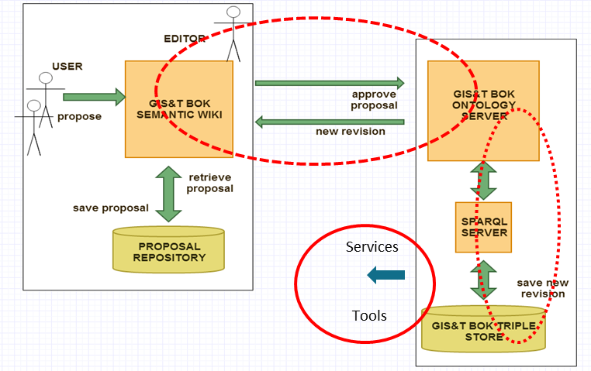

Figure 2: Overview of the architecture of the GiN2K platform (based on Ahearn at al., 2013)

The semantic wiki allows contributors to propose new concepts, changes to its content, new relationships, etc. The contributor is a regular user that can’t approve and integrate the changes in the repository. That is done by the editor. In practice the editors are the KA leaders and co-leaders of the GI-N2K consortium. They evaluate/review the proposed changes and accept or reject them. However, the wiki allows also to document and discuss the proposed changes so that final decisions are based on sound arguments, proposals and contra-proposals. After all, the BoK should be the result of a collaborative approach of the geospatial community.

Figure 3 shows the GI S&T semantic wiki. It has a text and graphical interface through which the BoK can also be explored. The wiki will be accessible by the public, but contributing to the wiki is based on a controlled access mechnaims according to the above describe pre-defined roles.



Figure 3: Graphical interface of the GI S&T semantic wiki

One of the tools developed is a curriculum design tool. The major interface is shown in figure 4.



Figure 4: Major interface of the curriculum design tool

The tool allows to design new curricula, to edit existing ones, to find and copy curricula and to compare them. The basic idea is that a curriculum can consist of up to three levels including lectures and practical works, courses and groups of courses or modules. Users can skip levels if they want so. The tool allows selecting and dragging concepts from the BoK into the defined curriculum as well as their abstracts. Abstract descriptions can be altered or extended. The curricula can of course be saved and printed.

The last activity line of the GI-N2K project is the organization of a series of workshops/plugfests to present the new BoK and the tools and to organize ‘hands-on’ exercises to explore the BoK and the tools and to test them according to well-defined ‘real-world’ use cases. One example is the design of a curriculum for vocational training on Spatial Data Infrastructures (SDI) and INSPIRE based on three job profiles (INSPIRE manager, data expert and service expert) and taking into account potential learning paths.

The workshops/plugfests started in May 2016 and will run until September 2016. They are planned in Girona (Spain), Debrecen (Hungary), Salerno (Italy), Helsinki (Finland), Salzburg (Austria), Sofia (Bulgaria), ‘s-Hertogenbosch (The Netherlands) and Barcelona (Spain). The workshops/plugfests are open and aim to create awareness about the BoK and to collect feedback on the BoK and the tools in order to improve them in the future.

**CONCLUSIONS**

The GI-N2K project was set-up to help bridging the gap between the current geospatial education and training offer and the needs of the market in this field. First two surveys on demand and supply of geospatial education and training were organised to assess the state-of-the-art and to provide input to the revision of the BoK. The latter was done with the help of a network of 150 geospatial experts: concepts were deleted, revised or added, and described in a ‘simple’ wiki. In parallel, a European ontology based paltform was set-up in the cloud and the revised BoK was uploaded in its triple store repository. Some RESTful services were developed on top of it to expose the content of the BoK to the GI-N2K tools. The priority tool developed is a curriculum design tool that allows defining, managing and comparing curricula. Test and validation plugfests started and will run through until September 2016.

The revision cycle which took one year followed a mixed approach, keeping the hierarchical aspects of the repvious BoK (by using units and topics), but also integrating the ontological aspects by adding and revising relationships (e.g. similarity). It should be stressed that the revision approach chosen allows to work step-by-step and to gradually evolve twaords a full ontology-based environment. Furthermore, the revision process is a continuous process and will go on, even after the end of the project. Finally it should be stressed that GI-N2K was a highly collaborative effort involving more than 200 people. The challenge for the future is to keep this rich network up and running beyond the project life cycle.

**REFERENCES**

1. Ahearn S.C., Icke, I., Datta, R., DeMers, M.N., Plewe, B., Skupin, A. (2013). Re-engineering the GIS&T Body of Knowledge. International Journal of Geographical Information Science, 27:11, 2227-2245. http://dx.doi.org/10.1080/13658816.2013.802324 [accessed 15.05.2016]
2. DiBiase, D., DeMers, M., Johnson, A., Kemp, K., Luck, A. T., Plewe, B., Wentz, E., Eds. (2006). Geographic Information Science & Technology Body of Knowledge. Washington, D.C., Association of American Geographers.

http://downloads2.esri.com/edcomm2007/bok/GISandT_Body_of_knowledge.pdf [accessed 15.05.2016]

1. European Union – European GNSS Agency (2015). GNSS Market Report, Issue 4, Luxembourg: Publications Office of the European Union
2. GI-N2K (2016). http://www.gi-n2k.eu
3. Painho, M. Curvelo, P. 2008: BoK e-Tool Prototype. An ontological-based approach to the exploration of Geographic Information Science & Technology Body of Knowledge. Proceedings Eugises 2008, Cirencester, UK. 8pp.

http://www.eugises.eu/proceedings2008/painho.pdf [accessed 15.05.2016]

1. Rip F.I., Lammeren, R.J.A. van, Bergsma A.R. (2014a). GI-N2K Supply survey. An exploratory survey about teaching geo-information in 28 European countries. Wageningen University CGI report 2014-2. Wageningen, the Netherlands.
2. Rip, F., Wallentin, G. and van Lammeren, R. (2014b). Integrated analysis of the demand for and supply of geospatial education and training: Results of the GI-N2K Surveys. GI-N2K Consortium: Leuven, Belgium.
3. Reinhardt, W. (2011). Geoinformatics education in different disciplines - challenges - approaches and experiences. In Hubeau, M., Steenberghen, T., Van Balen, K., Van Orshoven, J., Vileikis, O. (eds.). Leuven, Belgium: LeGIO Workshop, 18 November 2011, KU Leuven, p.21-28. https://ees.kuleuven.be/legio/ [accessed 15.05.2016]
4. Technavio (2015). GIS Market in Europe 2012-2016, Market Report
5. Vassiliou, A. (2014). Getting youth on the right path to bridge the skills gap. Speech at the launch of McKinsey Report on 'Education to Employment: Getting Europe's Youth into Work'. Brussels, January 13, 2014:

http://europa.eu/rapid/press-release_SPEECH-14-10_en.htm [accessed 15.05.2016]

1. Wallentin, G., Hofer, B., Traun, C. (2014). GI-N2K. Analysis of the demand for geospatial education and training (Task 1.1), Project Deliverable 1.1.1. University of Salzburg, Interfaculty Department of Geoinformatics – Z_GIS.

1. **Danny VANDENBROUCKE**, danny.vandenbroucke@kuleuven.be, Katholieke Universiteit Leuven, Spatial Applications Division Leuven (SADL),

   Address: Celestijnenlaan 200 E, 3001 Heverlee, Belgium, Tel. +32 486 713573.
2. **Dr. Glenn VANCAUWENBERGHE**, glenn.vancauwenberghe@kuleuven.be, Universiteit Leuven, Spatial Applications Division Leuven (SADL),

   Address: Celestijnenlaan 200 E, 3001 Heverlee, Belgium.
3. The project is part of the Lifelong Learning Programme (540409-LLP-1-2013-1-BE-ERASMUS-ENW)